Free silhouette images taken from the following sites:
http://www.supercoloring.com/
https://www.kissclipart.com/
https://www.allaboutbirds.org/
http://clipart-library.com/
https://www.silhouette.pics/60577/simple-kiwi-bird-silhouette.php (kiwi)
http://www.thehallofeinar.com/tag/arctic-skua/ (skua)
https://thenounproject.com/term/loon/20786/ (loon)
http://www.kiwiwise.co.nz/photo/kea-silhouette (kea)
http://www.craftsmanspace.com/free-patterns/parrot-silhouette-vector-pattern.html (parrot)
https://commons.wikimedia.org/wiki/File:Silhouette_of_a_red-winged_blackbird_(9011246361).jpg

RHEIFORMES
RHEIDAE
TINAMIFORMES
TINAMIDAE
CASUARIIFORMES
CASUARIIDAE
APTERYGIFORMES
APTERYGIDAE
ANSERIFORMES
ANHIMIDAE  ANATIDAE  DENDROCYGNINAE  ANSERINAE  Anser  Branta, part | 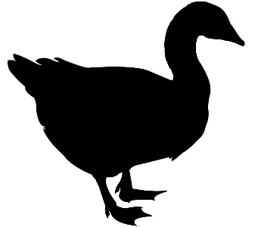
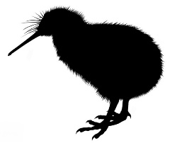

ANSERIFORMES
ANATIDAE  ANSERINAE  Branta, part  Cereopsis  Cygnus  Coscoroba  STICTONETTINAE  TADORNINAE  ANATINAE  Lophonetta  Speculanas  Nettapus  Aix  Chenonetta  Sibirionetta  Spatula  Mareca, part | 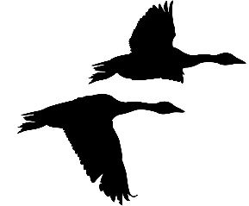
 | 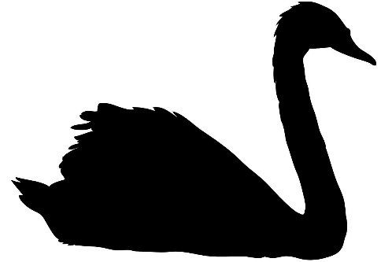
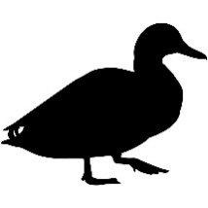

ANSERIFORMES
ANATIDAE
ANATINAE
Mareca, part
Anas
Malacorhynchus
Netta
Aythya
Polysticta
Somateria
Histrionicus
Melanitta
Clangula
Bucephala, part

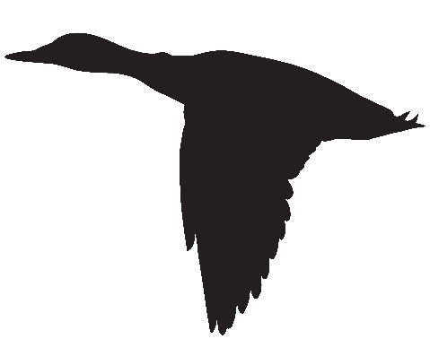

ANSERIFORMES
ANATIDAE  ANATINAE  Bucephala, part  Mergellus  Lophodytes  Mergus  Heteronetta  Nomonyx  Oxyura  Biziura | 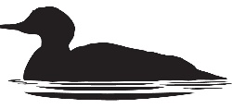
 | GALLIFORMES
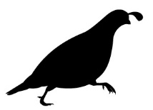 | MEGAPODIIDAE  CRACIDAE  NUMIDIDAE  ODONTOPHORIDAE  PHASIANIDAE  ROLLULINAE  PHASIANINAE
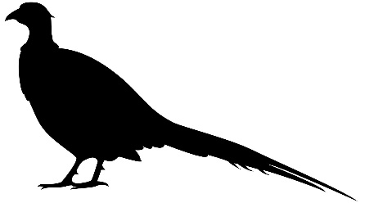

GALLIFORMES |  | 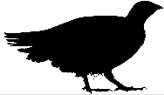
PHASIANIDAE
TETRAONINAE
MELEAGRIDINAE
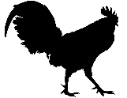 | CAPRIMULGIFORMES
 | PODARGIDAE  CAPRIMULGIDAE  NYCTIBIIDAE  STEATORNITHIDAE  AEGOTHELIDAE  APODIDAE  HEMIPROCNIDAE  TROCHILIDAE |  |  | 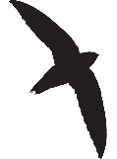
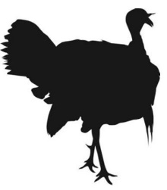
PTEROCLIFORMES |  |  | 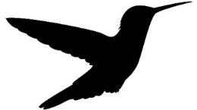
PTEROCLIDAE
COLUMBIFORMES
COLUMBIDAE
Columba

COLUMBIFORMES |  | 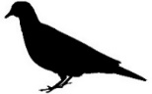
COLUMBIDAE, part
MUSOPHAGIFORMES  MESITORNITHIFORMES  OTIDIFORMES  CUCULIFORMES |  | 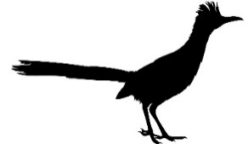
CUCULIDAE | 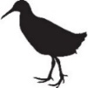
GRUIFORMES
RALLIDAE  HELIORNITHIDAE  ARAMIDAE  PSOPHIIDAE  GRUIDAE |  | 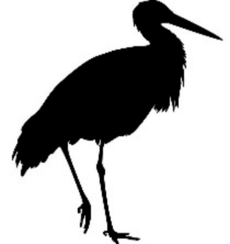
PODICIPEDIFORMES
PODICIPEDIDAE
PHOENICOPTERIFORMES
PHOENICOPTERIDAE
CHARADRIIFORMES
BURHINIDAE  RECURVIROSTRIDAE  HAEMATOPODIDAE, part |  | 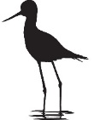

CHARADRIIFORMES
HAEMATOPODIDAE, part  CHARADRIIDAE  THINOCORIDAE  ROSTRATULIDAE  JACANIDAE  SCOLOPACIDAE  TURNICIDAE |  | 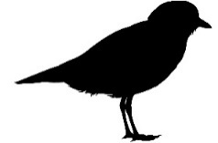
GLAREOLIDAE | 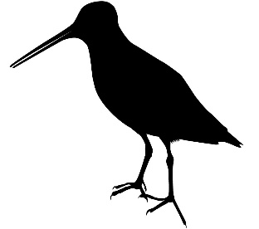
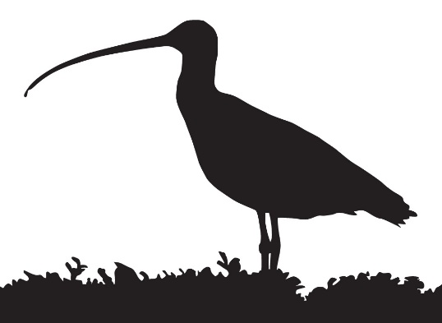

CHARADRIIFORMES
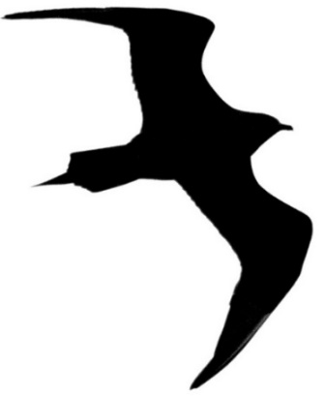 | STERCORARIIDAE  ALCIDAE  LARIDAE  LARINAE  Creagrus  Rissa  Pagophila  Xema  Chroicocephalus  Hydrocoloeus  Rhodostethia  Leucophaeus
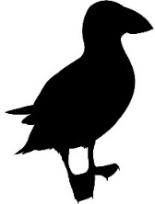 | 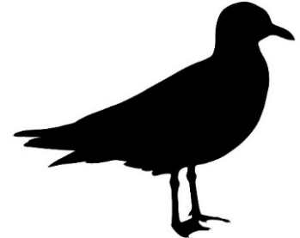

CHARADRIIFORMES
LARIDAE
LARINAE
Larus belcheri
crassirostris
heermanni
canus
delawarensis
occidentalis
californicus
argentatus
glaucoides
fuscus
schistisagus

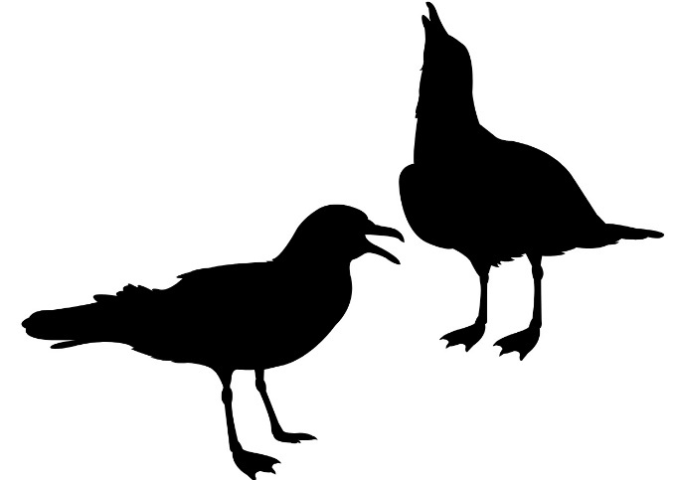

CHARADRIIFORMES
LARIDAE  LARINAE  Larus, part  STERNINAE  RYNCHOPINAE | 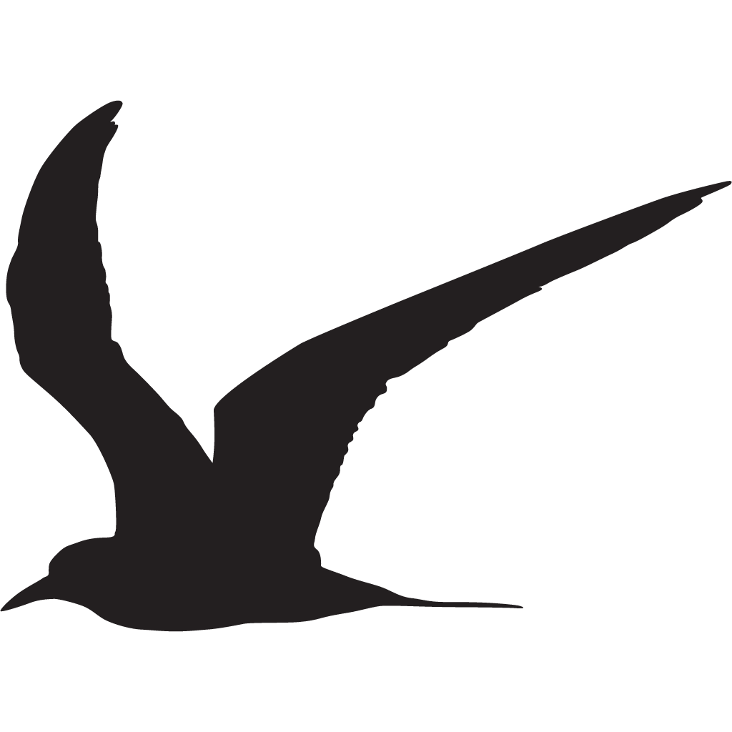
EURYPYGIFORMES
RHYNOCHETIDAE
EURYPYGIDAE
PHAETHONTIFORMES
PHAETHONTIDAE |  | 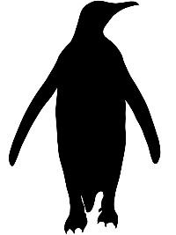
GAVIIFORMES
GAVIIDAE
SPHENISCIFORMES
SPHENISCIDAE
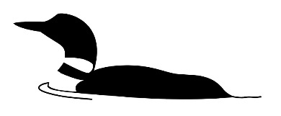

PROCELLARIIFORMES
DIOMEDEIDAE  OCEANITIDAE  HYDROBATIDAE  PROCELLARIIDAE |  | 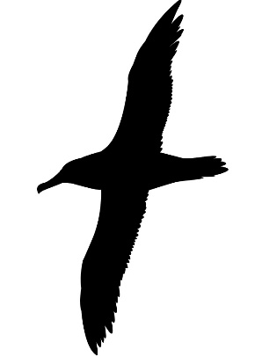
CICONIIFORMES
CICONIIDAE
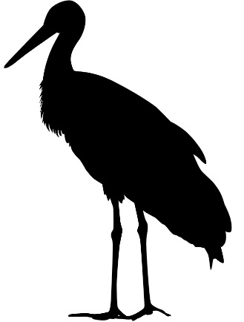
 | SULIFORMES
FREGATIDAE
SULIDAE
PHALACROCORACIDAE
ANHINGIDAE
 | 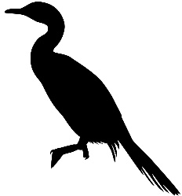

PELECANIFORMES
PELECANIDAE  BALAENICIPITIDAE  SCOPIDAE  ARDEIDAE  THRESKIORNITHIDAE |  | 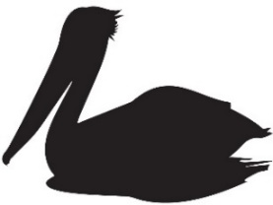
OPISTHOCOMIFORMES |  |  | 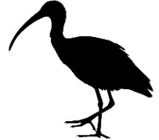
OPISTHOCOMIDAE
CATHARTIFORMES
CATHARTIDAE
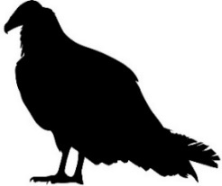 | 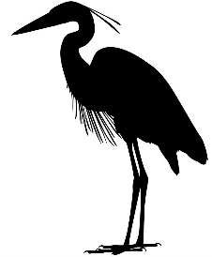

ACCIPITRIFORMES
PANDIONIDAE
ACCIPITRIDAE
ELANINAE
GYPAETINAE
ACCIPITRINAE
Aegypius  Gyps  Spilornis  Pithecophaga  Terathopius  Stephanoaetus  Spizaetus  Hieraaetus  Aquila  Melierax | Busarellus  Rostrhamus  Harpagus  Ictinia  Butastur  Circus  Accipiter  Milvus  Haliastur
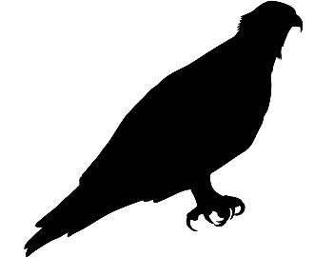 | 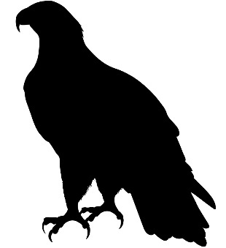

ACCIPITRIFORMES
ACCIPITRIDAE
ACCIPITRINAE
Haliaeetus
Geranospiza
Buteogallus
Rupornis
Parabuteo
Geranoaetus
Pseudaster
Leucopternis
Buteo
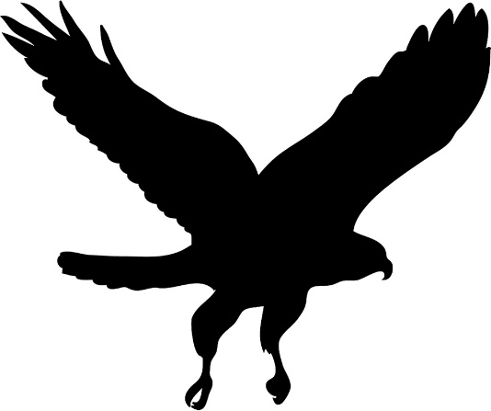

STRIGIFORMES
TYTONIDAE  STRIGIDAE  Otus  Psiloscops  Megascops  Pyrroglaux  Pulsatrix  Bubo virginianus  bubo  africanus  lacteus  scandiacus, part | 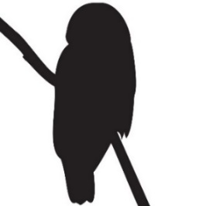
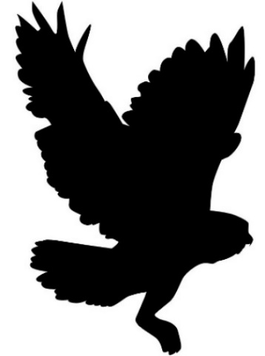

STRIGIFORMES
STRIGIDAE, part
COLIIFORMES
COLIIDAE
LEPTOSOMIFORMES
LEPTOSOMIDAE
TROGONIFORMES
TROGONIDAE
BUCEROTIFORMES
UPUPIDAE
PHOENICULIDAE
BUCEROTIDAE
CORACIIFORMES
TODIDAE
MOMOTIDAE
ALCEDINIDAE, part

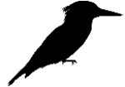

CORACIIFORMES
ALCEDINIDAE, part
MEROPIDAE
CORACIIDAE
BRACHYPTERACIIDAE
PICIFORMES
BUCCONIDAE
GALBULIDAE
LYBIIDAE
MEGALAIMIDAE
CAPITONIDAE
SEMNORNITHIDAE
RAMPHASTIDAE
INDICATORIDAE
PICIDAE
CARIAMIFORMES
CARIAMIDAE
FALCONIFORMES
FALCONIDAE, part

FALCONIFORMES
FALCONIDAE, part
PSITTACIFORMES
STRIGOPIDAE
CACATUIDAE
PSITTACULIDAE
PSITTACIDAE
PASSERIFORMES
EURYLAIMIDAE
PHILEPITTIDAE
CALYPTOMENIDAE
PITTIDAE
THAMNOPHILIDAE
CONOPOPHAGIDAE
GRALLARIIDAE
RHINOCRYPTIDAE
FORMICARIIDAE
FURNARIIDAE
PIPRIDAE
COTINGIDAE
TYRANNIDAE, part

PASSERIFORMES
TYRANNIDAE, part
TITYRIDAE
OXYRUNCIDAE
MENURIDAE
PTILONORHYNCHIDAE
CLIMACTERIDAE
MALURIDAE
MELIPHAGIDAE
PARDALOTIDAE
ACANTHIZIDAE
POMATOSTOMIDAE
ORTHONYCHIDAE
CINCLOSOMATIDAE
NEOSITTIDAE
CAMPEPHAGIDAE
PSOPHODIDAE
VIREONIDAE
PACHYCEPHALIDAE
ORIOLIDAE
FALCUNCULIDAE
OREOICIDAE
VANGIDAE
PLATYSTEIRIDAE
MALACONOTIDAE
AEGITHINIDAE
MACHAERIRHYNCHIDAE
ARTAMIDAE
RHIPIDURIDAE
DICRURIDAE
PARADISAEIDAE
CORCORACIDAE
IFRITIDAE
MONARCHIDAE
LANIIDAE
CORVIDAE, part

PASSERIFORMES
CORVIDAE
Cyanocitta, part
Aphelocoma
Garrulus
Cyanopica
Urocissa
Cissa
Dendrocitta
Crypsirina
Nucifraga
Pica
Pyrrhocorax
Ptilostomus
Corvus
CALLAEIDAE
PETROICIDAE
HYLIOTIDAE
STENOSTIRIDAE
PARIDAE, part

PASSERIFORMES
PARIDAE, part
REMIZIDAE
NICATORIDAE
ALAUDIDAE
PANURIDAE
MACROSPHENIDAE
HIRUNDINIDAE
CISTICOLIDAE
ACROCEPHALIDAE
PNOEPYGIDAE
LOCUSTELLIDAE
DONACOBIIDAE
PHYLLOSCOPIDAE
HYLIIDAE
AEGITHALIDAE
CETTIIDAE
PYCNONOTIDAE
SYLVIIDAE
ZOSTEROPIDAE
TIMALIIDAE
PELLORNEIDAE
LEIOTHRICHIDAE
REGULIDAE
DULIDAE
BOMBYCILLIDAE
MOHOIDAE
PTILIOGONATIDAE
CINCLIDAE
TURDIDAE
MUSCICAPIDAE
MIMIDAE, part

PASSERIFORMES
MIMIDAE, part  STURNIDAE  SITTIDAE  TICHODROMIDAE  CERTHIIDAE  POLIOPTILIDAE  TROGLODYTIDAE  DICAEIDAE  NECTARINIIDAE  CHLOROPSEIDAE  IRENIDAE  PEUCEDRAMIDAE  PLOCEIDAE  ESTRILDIDAE  VIDUIDAE  PRUNELLIDAE  PASSERIDAE  MOTACILLIDAE  FRINGILLIDAE  FRINGILLINAE  EUPHONIINAE  CARDUELINAE, part | 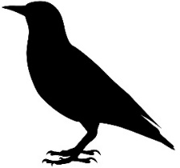
 | 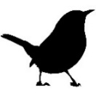
 | 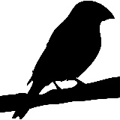

PASSERIFORMES
FRINGILLIDAE
CARDUELINAE
Pyrrhula
Bucanetes
Leucosticte
Haemorhous
Rhodospiza
Chloris
Crithagra
Linaria
Acanthis
Loxia
Carduelis
Serinus
Spinus
CALCARIIDAE
RHODINOCICHLIDAE

PASSERIFORMES
EMBERIZIDAE  PASSERELLIDAE  Pselliophorus  Pezopetes  Arremon  Arremonops  Atlapetes  Pipilo  Aimophila  Melozone  Peucaea  Oriturus  Spizelloides  Spizella  Pooecetes  Amphispiza  Artemisiospiza  Calamospiza  Passerculus  Ammodramus  Passerella  Melospiza, part | 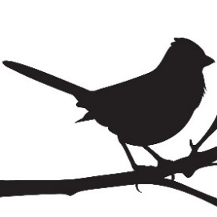
 | 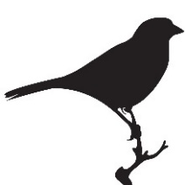
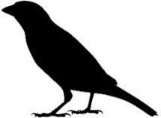

PASSERIFORMES
PASSERELLIDAE  Melospiza, part  Zonotrichia  Junco  Chlorospingus  Rhynchospiza  PHAENICOPHILIDAE  SPINDALIDAE  ZELEDONIIDAE | 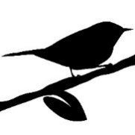
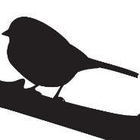 | PARULIDAE  Seiurus  Helmitheros  Parkesia  Vermivora  Mniotilta  Protonotaria  Limnothlypis
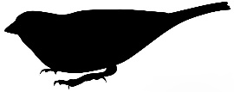

PASSERIFORMES
PARULIDAE  Oreothlypis  Oporornis  Geothlypis  Setophaga  Myiothlypis  Basileuterus  Cardellina  Myioborus | 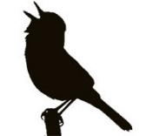
ICTERIIDAE
ICTERIDAE
XANTHOCEPHALINAE
DOLICHONYCHINAE
STURNELLINAE
Sturnella, part
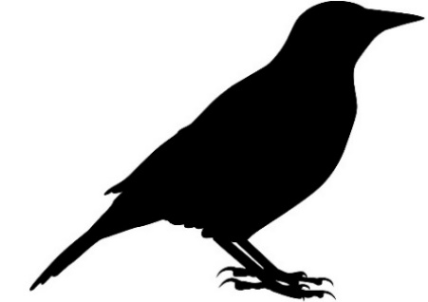

PASSERIFORMES
ICTERIDAE
STURNELLINAE
Sturnella, part
AMBLYCERCINAE
CACICINAE
ICTERINAE
AGELAIINAE
Agelaius, part
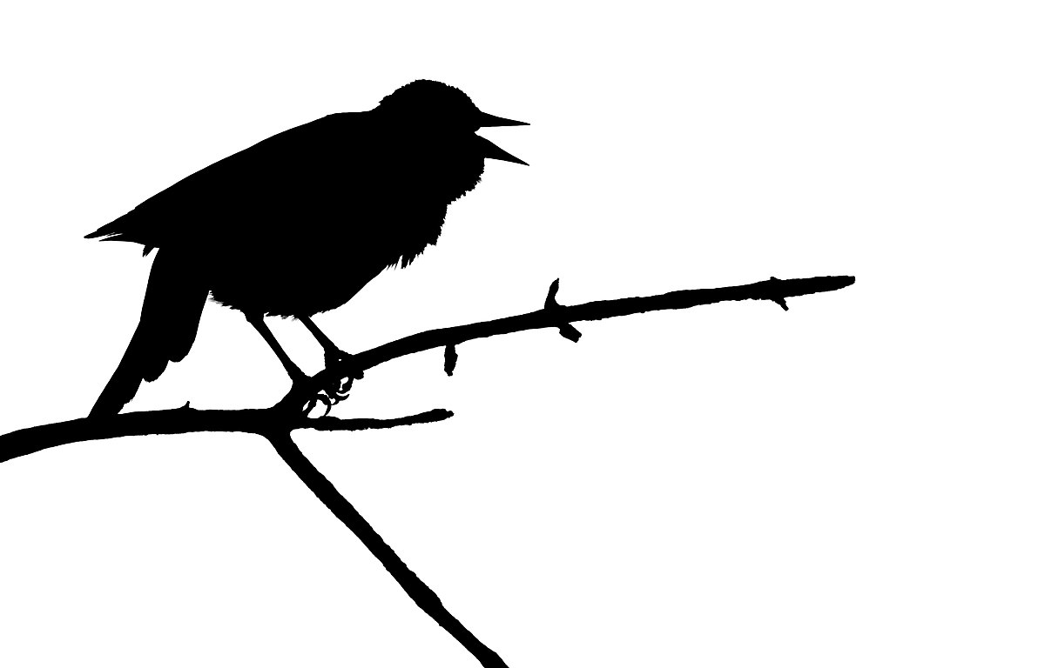

PASSERIFORMES
ICTERIDAE  AGELAIINAE  Agelaius, part  Molothrus  Dives  Euphagus  Quiscalus  Macroagelaius  Curaeus  Gnorimopsar  Oreopsar  Agelaioides  Chrysomus  Pseudoleistes  MITROSPINGIDAE  CARDINALIDAE  THRAUPIDAE | 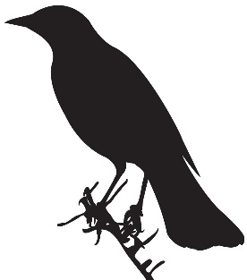
 | 